

Key Performance Indicators

**1. Total Sales Amount**

* **KPI:** The dashboard shows a total **sales amount of ₹986.6M**.
* **Main Highlight:** Zomato achieved nearly **₹1 billion in sales**, reflecting the high demand and reach.

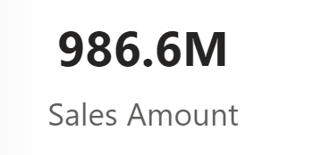

**2. Sales Quantity**

* **KPI:** The sales quantity is recorded at **2.4M units**, which measures the volume of items sold.
* **Main Highlight:** High sales quantity demonstrates effective market penetration and customer engagement.

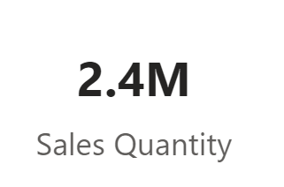

**3. Orders Count**

* **KPI:** Total number of orders is **150.3K**, showing the number of transactions made.
* **Main Highlight:** Substantial order count indicates a large and consistent customer base.

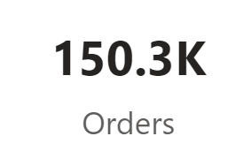

**4. Ratings**

* **KPI:** The dashboard captures **10K individual ratings** and an **overall rating of 148.5K**.
* **Main Highlight:** High rating count reflects active user engagement and customer satisfaction.

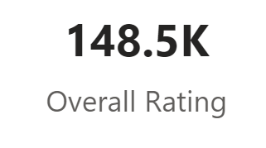

**5. Sales by Year**

* **KPI:** Year-over-year sales progression, with highlights on sales increases and decreases from 2017 to 2020.
* **Main Highlight:** Sales peaked significantly in **2019 at ₹0.41 billion**, showcasing a year of strong performance.

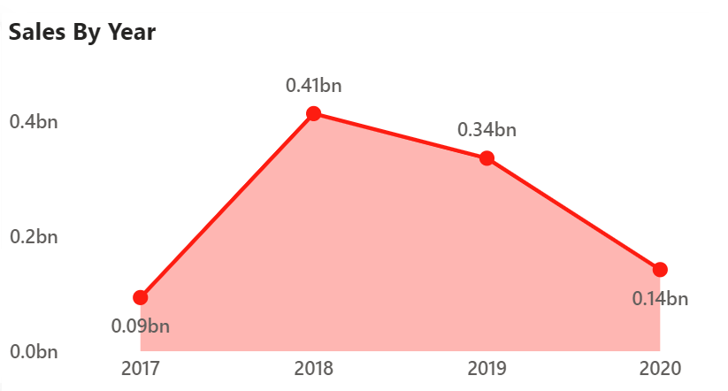

**6. Sales by Cities**

* **KPI:** Top-performing cities by sales, with **Tirupati** leading at **₹43M**, followed by **Electronic City** and **Baner, Pune**.
* **Main Highlight:** Tirupati stands out as the highest-grossing city, emphasizing its contribution to total sales.

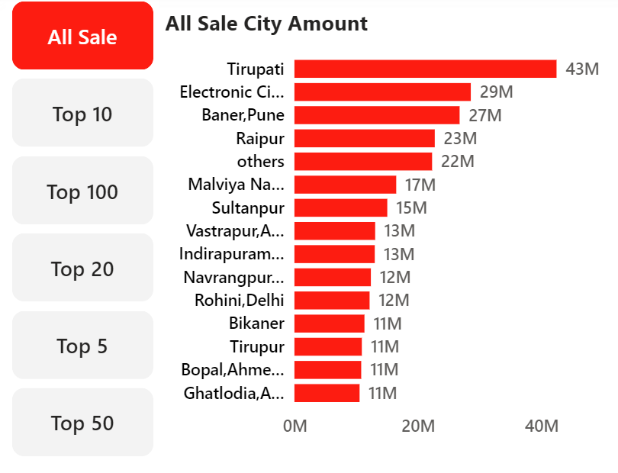

**7. Active Users**

* **KPI:** The number of **active users is 77.9K**, tracking user engagement and retention.
* **Main Highlight:** A solid active user base highlights Zomato’s reach and user loyalty.

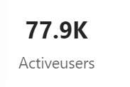

**8. User Performance by City**

* **KPI:** User activity by city, with areas like **Bikaner** and **Noida-1** showing strong user counts.
* **Main Highlight:** **Bikaner** has the highest active users, indicating strong engagement in this city.

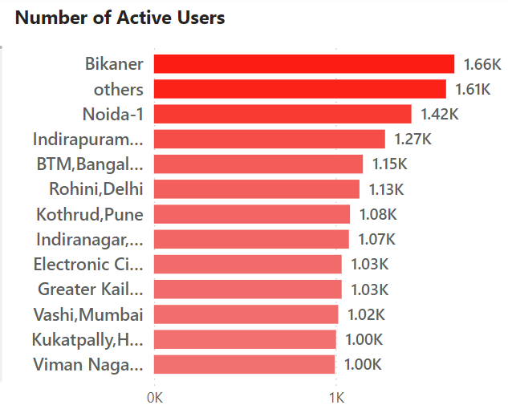

**9. User Demographics - Age Group**

* **KPI:** Breakdown of users by age, with the **20-30 age group** showing the highest interaction.
* **Main Highlight:** Highest engagement among 20-30-year-olds highlights a younger customer demographic.

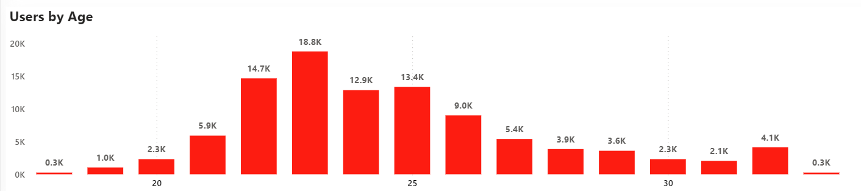

**10. Customer Acquisition and Retention**

* **KPI:** Data on gained and lost customers, showing **6.5K male** and **5.1K female** gained customers.
* **Main Highlight:** **Male customers** show higher acquisition rates, indicating a gender trend in user growth.

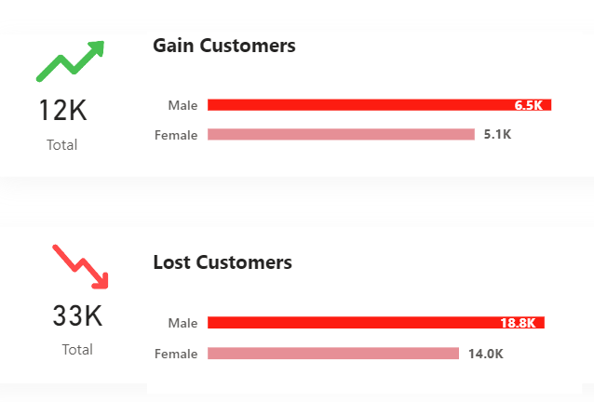

**11. Product Type Sales (Veg, Non-Veg, and Other Sales)**

* **KPI:** Breakdown of **Veg sales at ₹122M**, **Non-Veg at ₹106M**, and **Other sales at ₹24M**.
* **Main Highlight:** Veg items have the highest sales volume, suggesting a preference for vegetarian options.

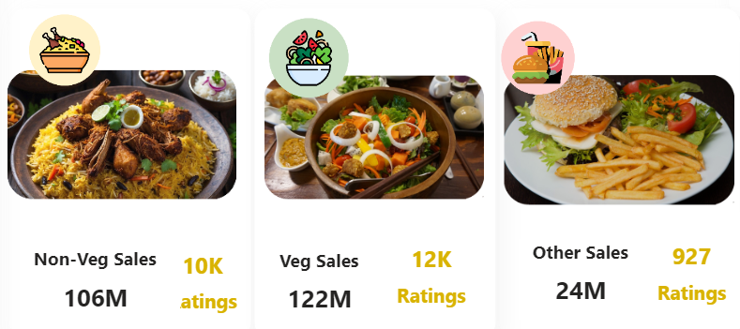

**12. Top Sales Cities and Ratings**

* **KPI:** Cities with the top ratings and sales, helping to identify locations with both high sales and positive feedback.
* **Main Highlight:** **Electronic City** and **Baner, Pune** appear as both high sales and well-rated areas, ideal for targeted marketing strategies.

